WORKING WITH DML
- Write an UPDATE statement that changes all NULL values of the AddressLine2 column in the dbo.demoAddress table to 'N/A'.
UPDATE dbo.demoAddress
SET AddressLine2 = 'N/A'
WHERE AddressLine2 IS NULL;

Output
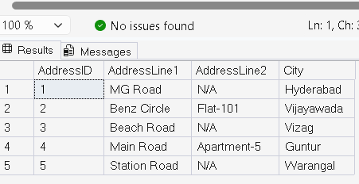

- Write an UPDATE statement that corrects the UnitPrice with the ListPrice of each row by joining demoSalesOrderDetail with demoProduct.
UPDATE d
SET d.UnitPrice = p.ListPrice
FROM dbo.demoSalesOrderDetail d
INNER JOIN dbo.demoProduct p
ON d.ProductID = p.ProductID;

Output
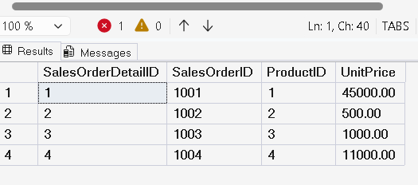

- Write a query that deletes the rows from dbo.demoCustomer where the LastName begins with the letter S.
DELETE
FROM dbo.demoCustomer
WHERE LastName LIKE 'S%';

Output
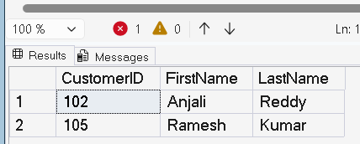

- Delete the rows from dbo.demoCustomer if the customer has not placed an order or if the TotalDue is less than 1000.
DELETE c
FROM dbo.demoCustomer c
WHERE
NOT EXISTS
(
SELECT *
FROM dbo.demoSalesOrderHeader h
WHERE h.CustomerID = c.CustomerID
)
OR
(
SELECT ISNULL(SUM(TotalDue),0)
FROM dbo.demoSalesOrderHeader h
WHERE h.CustomerID=c.CustomerID
) < 1000;

SELECT * FROM dbo.demoCustomer;

Output
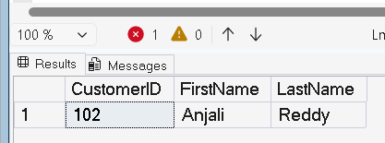

5) CREATE TABLE dbo.demoProduct
(
ProductID INT PRIMARY KEY,
Name NVARCHAR(100) NOT NULL,
Color NVARCHAR(15),
StandardCost MONEY NOT NULL,
ListPrice MONEY NOT NULL,
Size NVARCHAR(5),
Weight DECIMAL(8,2)
);
Output
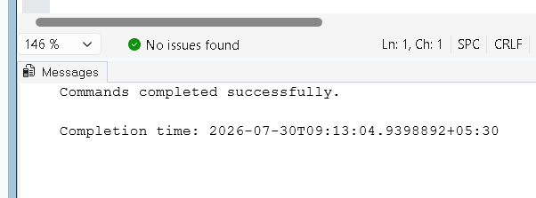

6)Insert five rows into dbo.demoProduct table.
INSERT INTO dbo.demoProduct
(ProductID,Name,Color,StandardCost,ListPrice,Size,Weight)
VALUES
(1,'Laptop','Black',40000,45000,'15',2.50),
(2,'Mouse','White',300,500,NULL,0.20),
(3,'Keyboard','Black',700,1000,NULL,0.80),
(4,'Monitor','Black',9000,11000,'24',4.20),
(5,'Printer','Gray',6000,7500,NULL,6.00);

Output
